**MATHEMATIS SEVENTTH GRADE**

**TALLER ACTIVIDAD COMPLEMENTARIA**

**FECHA DE ENTREGA Y SUSTENTACION DIA 22 DE MARZO**

**TEACHER: YOLIMA NÚÑEZ QUINTERO**

**STUDENT: _____________________________________________________**

1. 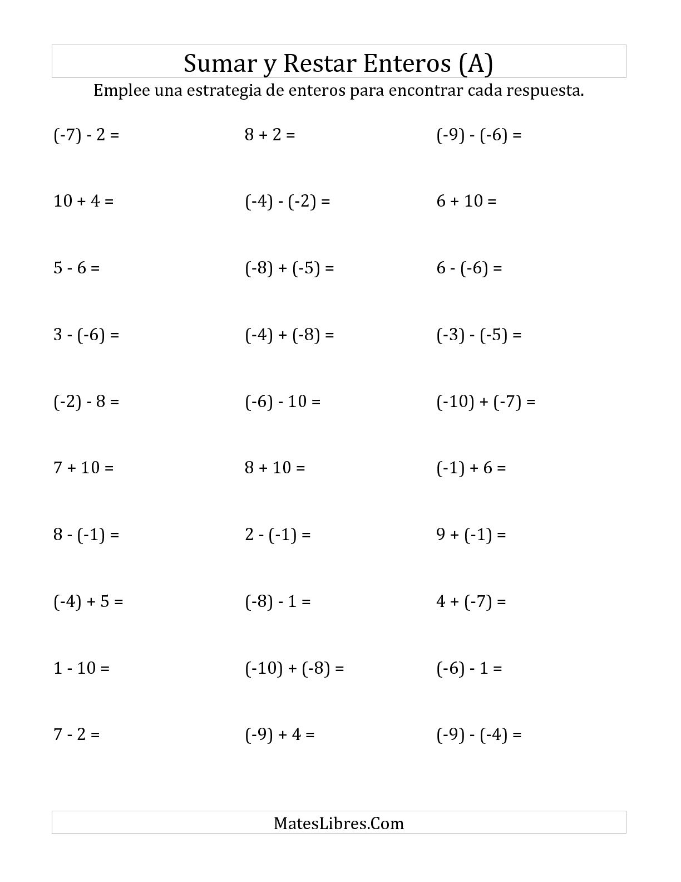RESOLVER :

